

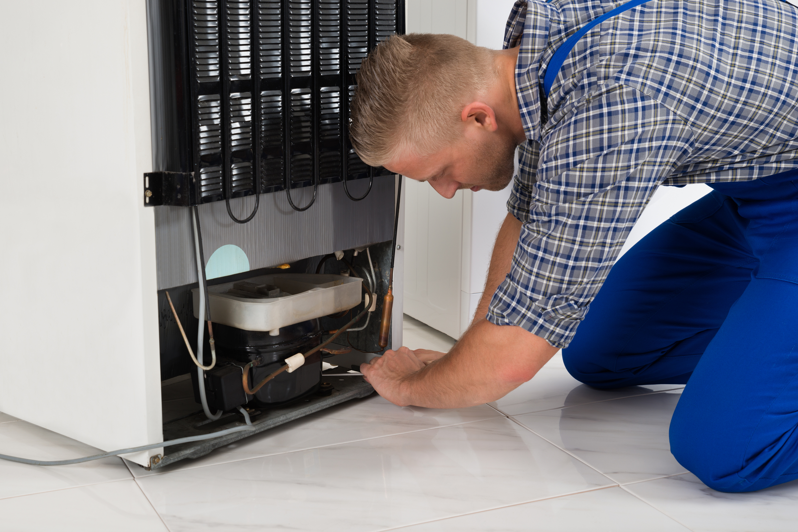

Includes Covid-19 Prevention
  - Domestic Appliance Repair (Freestanding)
RISK ASSEMENT
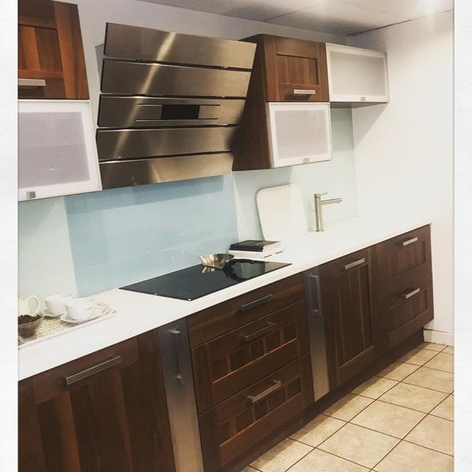
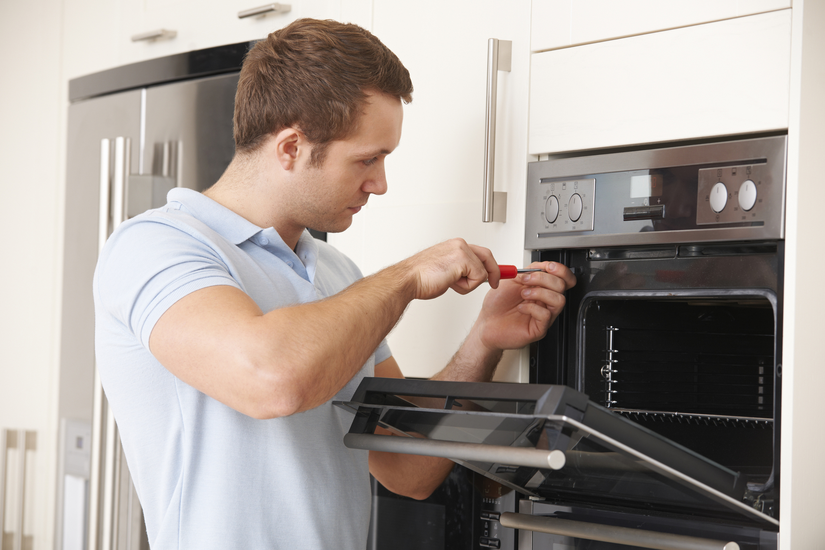
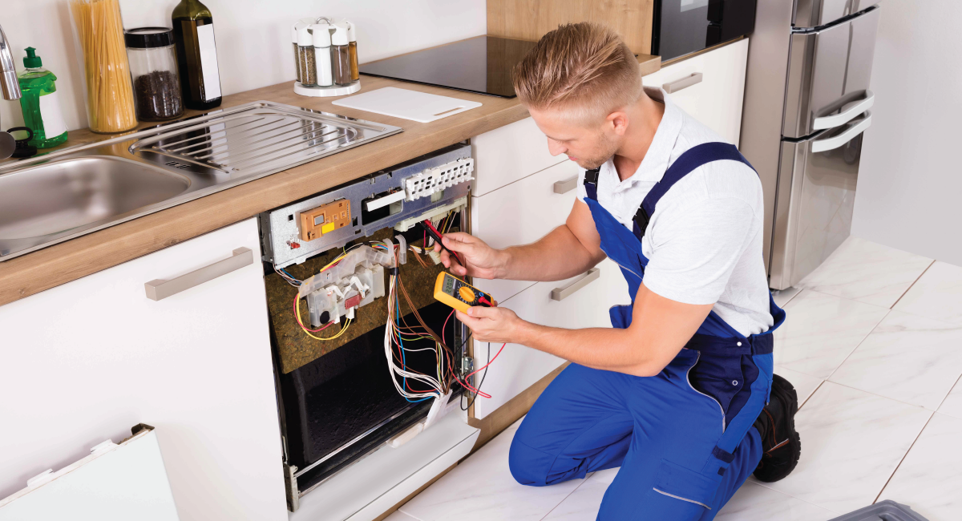
Task | Repair & Inspection of Domestic Appliances in occupied properties
Task/Activity | Repairing freestanding domestic electrical appliances into a customer’s property
Assessor | Rob Chappell | Location of Assessment | Various – Customers home address

Risk Rating Matrix (RR) | Likelihood (L)
Severity (S) | Certain or near certain to occur (High) | Reasonably likely to occur (Medium) | Unlikely to occur (Low)
Fatality; major injury or illness causing long term disability (High) | HIGH (H) | HIGH (H) | MEDIUM (M)
Injury or illness causing short term disability (Medium) | HIGH (H) | MEDIUM (M) | LOW (L)
Other injury or illness (Low) | MEDIUM (M) | LOW (L) | LOW (L)
Sites Operated by the Group:
DBE Ltd
1 Kelvin Park, Dock Road
Birkenhead
CH41 1LT
0151 647 3633

Ref | Hazards | Who is at risk? | Controls in place | L | S | RR | Adequately controlled?
1. | Exposure to COVID-19 virus from others due to having come into close contact (within 2 metres for 15 minutes or more) | Employees/Staff & Third Parties | - Employees to wear full PPE equipment at all times.  - Employees to keep a minimum distance of 2-metres from the customer as much as possible.  - When approaching doors staff are to knock and then stand back 2-metres.  - Employee to confirm that customer or residents are NOT ill or self-isolating, if they are employees are NOT to enter the property.  - Employee to explain what they will be doing and then ask customer to step back and go to another room, taking all valuables with them.  - Employee not to enter property until customer has left the room | M | M | M | Yes
2. | Manual Handling, risk of injury from incorrect moving leading to possible long-term serious injury | Staff | - Employees must take note of the size and weight of the appliance.  - Only lift what you are comfortable lifting / moving without the risk of injury.  - Use all supplied equipment to help move appliances, such as sack trucks or electric stair climbers.  - Use two people to move appliances in confined spaces or if you feel you need help.  - Remember T.I.L.E –  TASK – What are you doing, can you do it safely?  INDIVDUAL – Remember only lift or move what you can safely manage.  LOAD – What are you lifting / moving? Can you grip it safely? Use safety equipment to help you – ask for further support if you need it.  ENVIROMENT – Where are to moving the appliance from & too? Is your path clear? Are there any steps or narrow places? Remove any trip hazards and always take the shortest, safest route. | M | H | M | Yes
3. | Slips, Trips and Falls, resulting in injury or sprains or broken bones | Staff / customer | - Ensure you wear closed, approved safety boots or shoes  - Keep a look out for uneven surfaces or broken paths or potholes etc.  - No working at height is authorised  - Ensure your working area is well lit  - Clear up any spillages you find, check especially after installing any appliance that uses or produces water.  - Do not leave appliance wrappings lying around, clean up as you go.  - Keep your tools in one place and all accounted for, do not leave them lying around.  - Observe and obey any signage, such as ‘wet floor’ and take extra care in these areas, follow any verbal instructions you are given. | M | M | M | Yes
4. | Risk of electric shock, resulting in burns or loss of life | Staff | - Ensure power supplies have been full disconnected before starting to disconnect or reconnect any appliances you are working on.  - Power tools are only to be used by competent & trained employees and full instructions on its safe operation must be followed. Only battery-operated power tools are authorised for use.  - Full electrical testing to be completed on appliances installed to ensure continuity test are correct and all electrical connections are double checked to ensure no exposure to cables. | H | M | M | Yes
5. | Working at height, risk of falls resulting in injury, broken bones or long-term health problems | Staff / Customers | - Only used step ladders approved by the company  - No more than 5 runs high  - Two employees required for working at height  - Ladders must only be used on firm, flat & level surfaces. | M | M | M | Yes

PPE for Covid-19 includes, Face mask, Clear full-face visor, Gloves and hand sanitiser.

Always call for help & support if in doubt.
Follow manufacturer’s instructions.
Use equipment to reduce manual. handling.
Always use all PPE provided to you.

Date of Assessment | 18/04/2022 | Signature | R. Chappell
Review date | 18/04/2023

